**Bear - Wooden Animal Wall Mount**

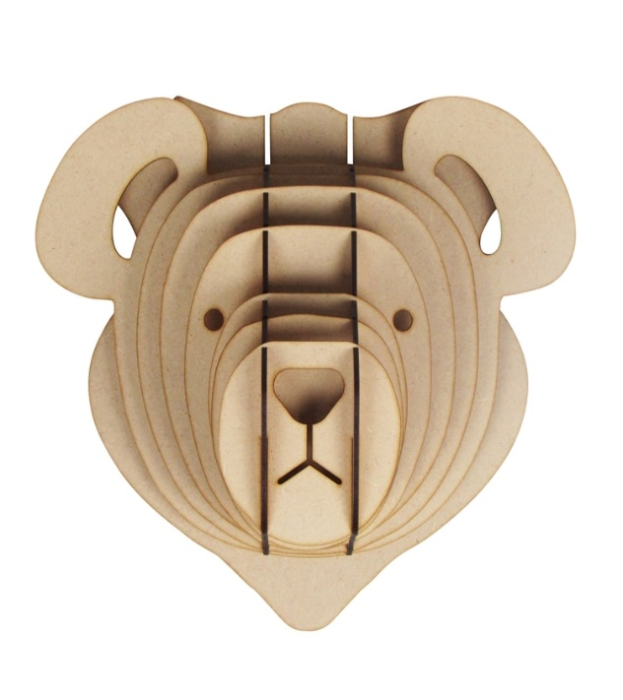The Bear Wooden Animal Wall Mount is a bold and striking decor piece that brings the raw beauty of the wilderness into your home. Crafted from high-quality wood, this mount features a detailed, intricately carved bear head, capturing the power and majesty of the animal. The rich, natural wood finish adds a rustic, organic touch, making it a perfect addition to cabins, modern rustic interiors, or nature-inspired spaces. With its commanding presence, the Bear Wooden Wall Mount serves as a strong focal point, ideal for animal lovers or anyone looking to add a wild, yet refined, aesthetic to their decor.